**NAME: ABDURRAHMAN QURESHI**

**ROLL NO: 210451**

**EXP2.1**

**HTML code for the above exercise.**

_________________________________________________________________________________

**Code:**

<html>

<head>

<title></title>

</head>

<body>

<h1 align="centre">H1 tag with centre aligned</h1>

<h2 align="left">H2 tag with left aligned</h2>

<h3 align="right">H3 tag with right aligned</h3>

<h4>H2 tag without aligned</h4>

<h5>H2 tag with left aligned</h5>

<p>Example of paragraph</p>

<p>New sentence without paragraph break</p>

</body>

</html>

_________________________________________________________________________________

**Output:**

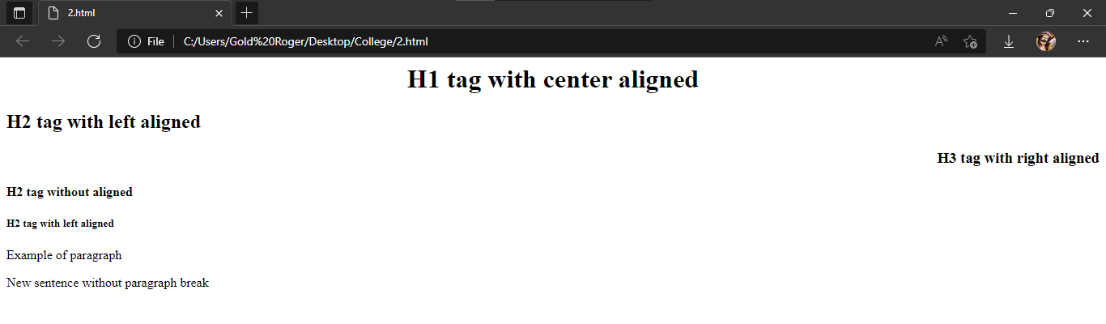

**EXP2.2**